


SIMATS ENGINEERING
Saveetha Institute of Medical and Technical Sciences
Chennai- 602105
Student Name: Jecinda Shirly.S Reg. No.:192521024
Course Code:CSA0202 Slot:C
Course Name:C Programming
Course Faculty:Dr.V.Jayasudha
Project Title: Hospital Patient Monitoring System

Module Photographs: (3 photographs –Module Photo, Individual student contribution module work in
the project and presentation image)
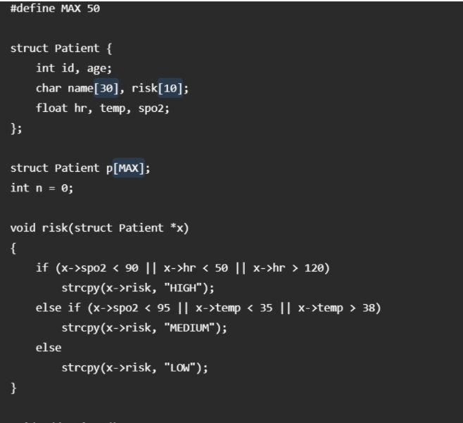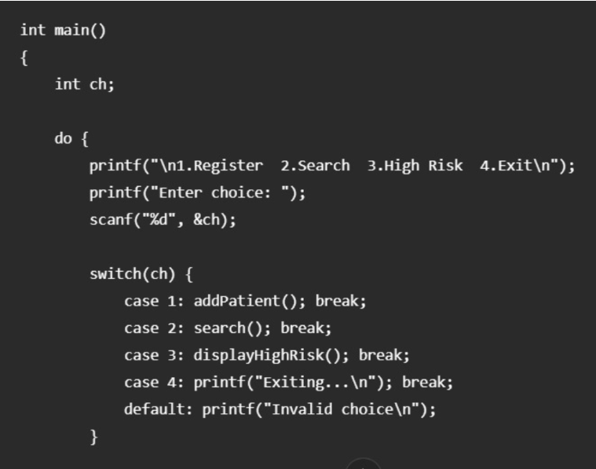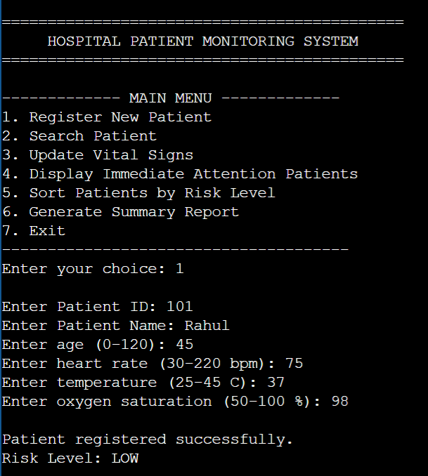
Project Description: (here you write what you did in this project (contribution) including Model
Description
My contribution to the Hospital Patient Monitoring System focused on implementing the emergency priority classification, patient sorting, and display of high-priority patients. The system monitors important physiological parameters such as heart rate, body temperature, and oxygen saturation to determine the risk level of each patient. I worked on developing the classification logic to categorize patients into HIGH, MODERATE, and LOW risk levels based on their monitored values. The emergency priority feature was implemented to identify patients whose vital signs indicate a critical condition and who may require immediate medical attention. I also developed the functionality to display high-priority patients separately so that critical records can be identified easily. In addition, I implemented the sorting mechanism to arrange patient records according to their risk level, giving higher priority to critical patients. The sorting functionality helps healthcare staff quickly understand the priority of patients and focus on those requiring urgent monitoring. I tested the implemented functions using normal, boundary, and critical input values to verify the correctness of the risk classification and sorting operations.

Student Signature Guide Signature

